5th June 2018.

To: Each Member of the Joint Policing Committee.

Re: Meeting of the Joint Policing Committee

Dear Member,

I wish to inform you that the next meeting of the Joint Policing Committee will take place in the Council Chamber, Aras an Chontae, Great Water Street, Longford, on
Monday, 11th June 2018 as follows -
3.00 p.m. - JPC Meeting - “In Committee” to consider operational matters.
3.30 p.m. - June 2018 JPC Meeting.

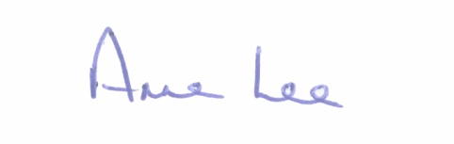
Yours sincerely,

___________________
Anne Lee,
Administrative Officer.
AGENDA

1. Confirmation of Minutes of Joint Policing Committee meeting held on the
5th March 2018 - enclosed.

2. Matters arising.
3. Presentation by the Criminal Assets Bureau.
4. Garda Report.
5. Local Authority Report.
6. Update on CCTV.
7. Update on Longford Joint Action Plan.
8. Date of next meeting - 10th September 2018.

